Survey for Parents: Children, food and family mealtimes
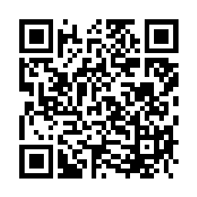
Scan the QR code above using a QR scanning app which will bring you directly to the survey on your smartphone.

